**EINVis Software Tutorial**

This document describes how to use EINVis software through one example process. It will give some screenshots to describe how to use EINVis.

We recorded two video tutorials, and uploaded them to Youtube:

EINVis Tutorial Part 1: <http://youtu.be/xUnBA1w8_uU>

EINVis Tutorial Part 2: <http://youtu.be/UvScGCubwDM>

You can visit EINVis Tutorial webpage to watch them: <http://filer.case.edu/yxw407/einvis/tutorial.html> . You can watch them in 1080p HD resolution.

**1. Link to Run EINVis Online**

This section is about how to link to EINVis webpage by use of a web browser.

You can click this link (<https://filer.case.edu/yxw407/einvis/run/>) and directly link to run EINVis online. Or you can go to the homepage of EINVis (<http://filer.case.edu/yxw407/einvis/>), as shown in Fig. 1, click the “Run” tab to go to the “Run” webpage, as shown in Fig. 2. Click on the “Run EINVis” link in the “Run” webpage, as shown in Fig. 3, to run “EINVis” online.

IE browser may require the installation of Google Chrome Frame, as shown in Fig. 4. Since EINVis uses many new HTML5 features, which are not supported very well by IE, so please install this plugin. Google Chrome Frame is free to install. If you are using Google Chrome web browser, EINVis will not prompt this dialog. When it requires to install Google Chrome Frame, click on “Get Google Chrome Frame” button in Fig. 4. Then, you can see the dialog shown in Fig. 5. Click on “Accept and Install” button to continue. It may take some time to install Google Chrome Frame. Please wait, until it prompts the dialog that says “Thanks for installing Google Chrome Frame”. It represents that Google Chrome Frame is successfully installed on your computer. Then, it will go to run EINVis webpage automatically, so we can get the initial interface of EINVis, as shown in Fig. 6.

**2. User Interactions in EINVis**

This section shows how to use EINVis to visualize and explore the epistatic interaction network. It will describe the user interactions in EINVis through an example, while it will also give some screenshots to show the interactions effect.

**2.1 Run Demo**

In the initial interface of EINVis, as shown in Fig. 6, click the red “Demo” button to begin rendering one demo dataset. The demo dataset can be downloaded from “EINVis Demo Data Files” link on the “Run” webpage. EINVis will read these files from server automatically after user clicks the “Demo” button. The initial render result is shown in Fig. 7. The initial result includes two different views. The left bubble is the EIN tree ring view, and the right bubble is the EIN matrix view.

**2.2 Interact with EINVis**

EINVis provides user mouse interactions, as well as controls to let the user interact with the visualizing process.

The user can adjust the “Edge Number” slider to increase the number of edges, as shown in Fig. 8. The user can also adjust the “Font Size” slider to decrease the font size of node name, as shown in Fig. 9. When the font size of the node name is decreased, the width of the three levels in the ring will also decrease correspondingly.

Sometimes, the edges are crossing and overlapping with each other, so it is not quite clear about which nodes are interacting with each other. The user can adjust the “Edge Bundle” strength slider to bundle adjacent edges together to reduce the clutter and enhance visualization. Fig. 10 shows that when the user moves the slider to the minimum position, the edge lines become straighter.

If there are too many nodes shown in the EIN tree ring view, and the node name may affect the user to observe the node color. So we provide one function that the user can uncheck the “Node Name” checkbox to hide all the node names, as shown in Fig. 11. Then the user can focus on the color patterns. When the user observes one interested pattern, and wants to see what the node name is, the user can check the “Node Name” checkbox to show the node name again.

The user can uncheck “Black Background” checkbox to show the white background, as shown in Fig. 12. We recommend black background, since the edge curve lines with light color will become invisible under the white background.

If the user wants to see how other SNPs interact with an interested SNP, he/she can use the operation “S” + Click to select one node. Then all related nodes and induced edges will be highlighted with color, as shown in Fig. 13. The user may also want to observe how other SNPs interact with a set of interested SNPs. We also provide the function to select multiple nodes and track interacting nodes. In Fig. 14, two nodes are selected. The user can use “U” + Click operation to unselect one node. If we unselect node “rs10851885”, the EIN tree ring view will become Fig. 13 again.

Previously, we highlight all the nodes related to any of the selected nodes. We can also change to highlight all the nodes related to all selected nodes, by switching to the highlight “All” from “Any” radio button, as shown in Fig. 15. We can see only one SNP “rs884401” interacts with both of the two selected SNPs “rs1078324” and “rs10851885”.

When there are too many nodes in the EIN tree ring view, each node space becomes narrow. In this case, we need to collapse some uninterested nodes to save space in order to show more important nodes. Fig. 16 shows that we collapse many nodes. We can also expand the chromosome node “1” again, as shown in Fig. 17. In Fig. 17, many nodes that are unrelated to the selected SNPs “rs1078324” and “rs10851885” are collapsed. So, we can focus on the interactions related to these two selected SNPs. We can also see the SNP-gene or gene-gene interactions by expanding or collapsing other nodes further. From this example, we can see that not only we can focus on the interested nodes, but also we can observe the interactions at different levels, i.e. SNP-SNP, SNP-gene and gene-gene interactions. Therefore, collapsing and expanding are useful functions to explore the network.

The user can change the color bar of nodes and edges by use of the drop-down menu after the labels “Node Color Bar” and “Edge Color Bar” respectively. Fig. 18 shows that the user changes the node color bar, and Fig. 19 shows that the edge color bar is changed. We provide 13 different color bars, most of which are selected from ColorBrewer. These color bars are optimal for user to distinguish the color differences. Node color bar and edge color bar can be configured independently.

EINVis provide the “View Rank” button. When user clicks on this button, EINVis will open a new webpage and show the rank of SNPs based on the degree of each SNP. The binomial distribution p-value will also be calculated by EINVis. The screenshot of rank of SNPs is shown in Figure 20.

If user want to see a specified gene or SNP, he/she can search for this gene or SNP through the “Search” box. For example, in Figure 21, user inputs a gene name “nrg”, and all matched genes “NRG1”, “NRG3”, and “NRG4” are highlighted with colors.

If the user wants more detailed information about one SNP or gene, he/she can link to NCBI website by use of “L” + Click operation. Then, EINVis will open a new NCBI webpage for the selected SNP or gene. Fig. 22 shows that the user looks up one SNP “rs1078324” in NCBI database website; and Fig. 23 shows that the user looks up one Gene “PPARGC1B” in NCBI database website.

The EIN Matrix View is an auxiliary view to the EIN tree ring view. Fig. 24 shows that we move the EIN matrix view bubble to the center. The color scheme is the same as that in the EIN tree ring view. The left margin and top margin show the SNP name list in the format of “gene.SNP_name”. The background color represents the single-locus test value. In the matrix, each square (entry) represents whether or not the two SNPs have interactions. If the entry is gray, then there is no interaction. If it has a color, then the color represents the two-locus test value. Since the view space is limited, we can only show part of the interaction matrix at one time. We provide the pan function (Drag Mouse inside EIN matrix view bubble), so the user can pan the matrix to view other parts of the EIN matrix view. Fig. 25 shows that the user pans the EIN matrix view to right bottom region. The user can just click on any region of EIN tree ring view bubble to switch back to EIN tree ring view bubble.

The LD Tree Ring view is another auxiliary view to the EIN tree ring view. It has the same layout, but the edge information are replaced with the LD information, as shown in Figure 26.

**3 Load Data Files**

**3.1 Download the Demo Data Files**

In the “Run” webpage, as shown in Fig. 3, find the “EINVis Demo Data Files” link, click it and save the file to a local path. Uncompress the downloaded “zip” file, and you will see two “.txt” file: “01NodesFile.txt” and “02EdgesFile.txt”.

**3.2 Prepare Your Own Data Files**

About the data file format, please refer to “Documents” (<http://filer.case.edu/yxw407/einvis/docs.html>) webpage, or the PDF version of user manual document, which can be found in “Documents” webpage.

**3.3 Load Data Files**

EINVis needs two input files: Nodes file and Edges file. You can select the demo data files downloaded in previous section. The user can also load his/her own data files and visualize them.

Fig. 26 shows that the user clicks “Choose File” button under the “Nodes File” label to load a new nodes file. Fig. 27 shows that the user clicks the “Choose File” button under the “Edges File” label to load a new edges file. And Fig. 28 shows that the user clicks “Start Rendering” button to start rendering the views for the new dataset.

In conclusion, this document gives an example to show how to use EINVis software. It shows how to link to run EINVis online. It gives some screenshots to show how to interact with EINVis to visualize and explore the epistatic interaction network. It also shows how to input data files and visualize new datasets.

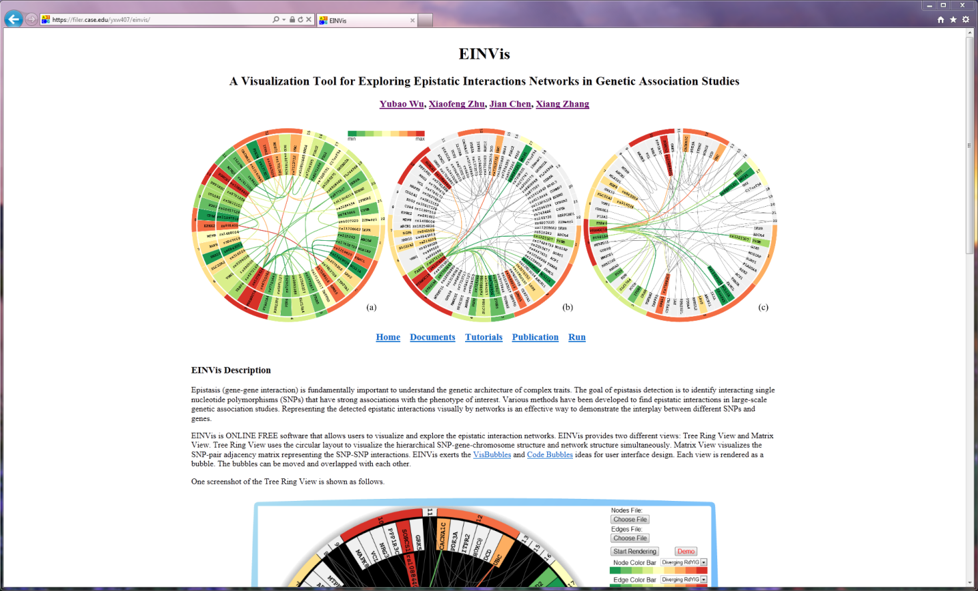

Fig. 1. Homepage of EINVis (<http://filer.case.edu/yxw407/einvis/>)

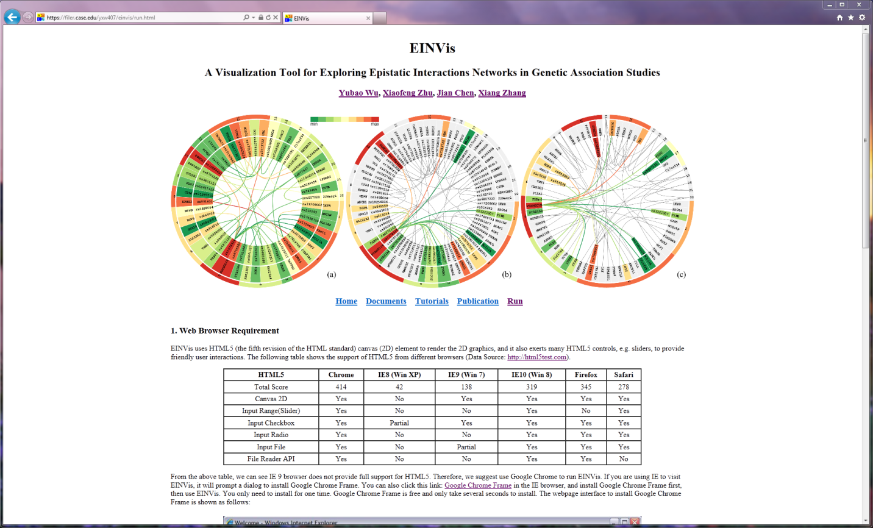

Fig. 2. “Run” tab webpage.

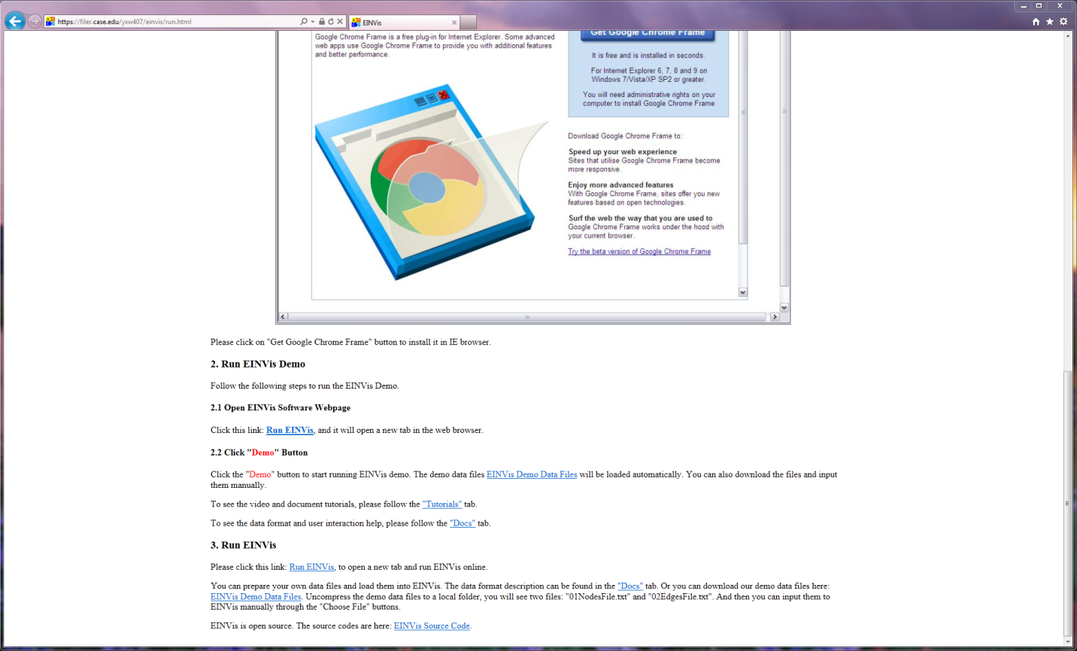

Fig. 3. Click “Run EINVis” in section “2.1 Open EINVis Software Webpage” to Run EINVis Demo.

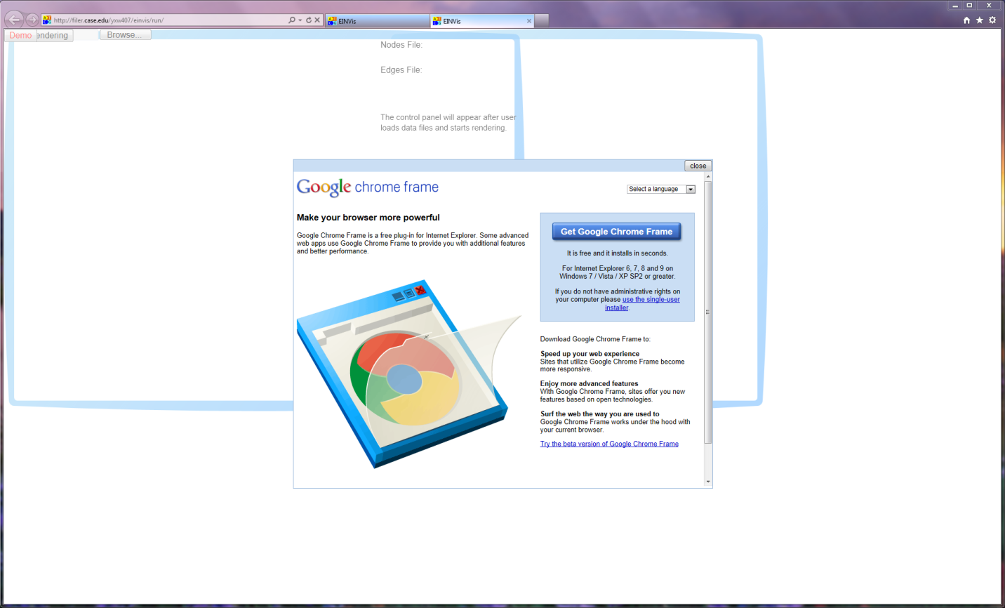

Fig. 4. IE browser may require to install Google Chrome Frame.

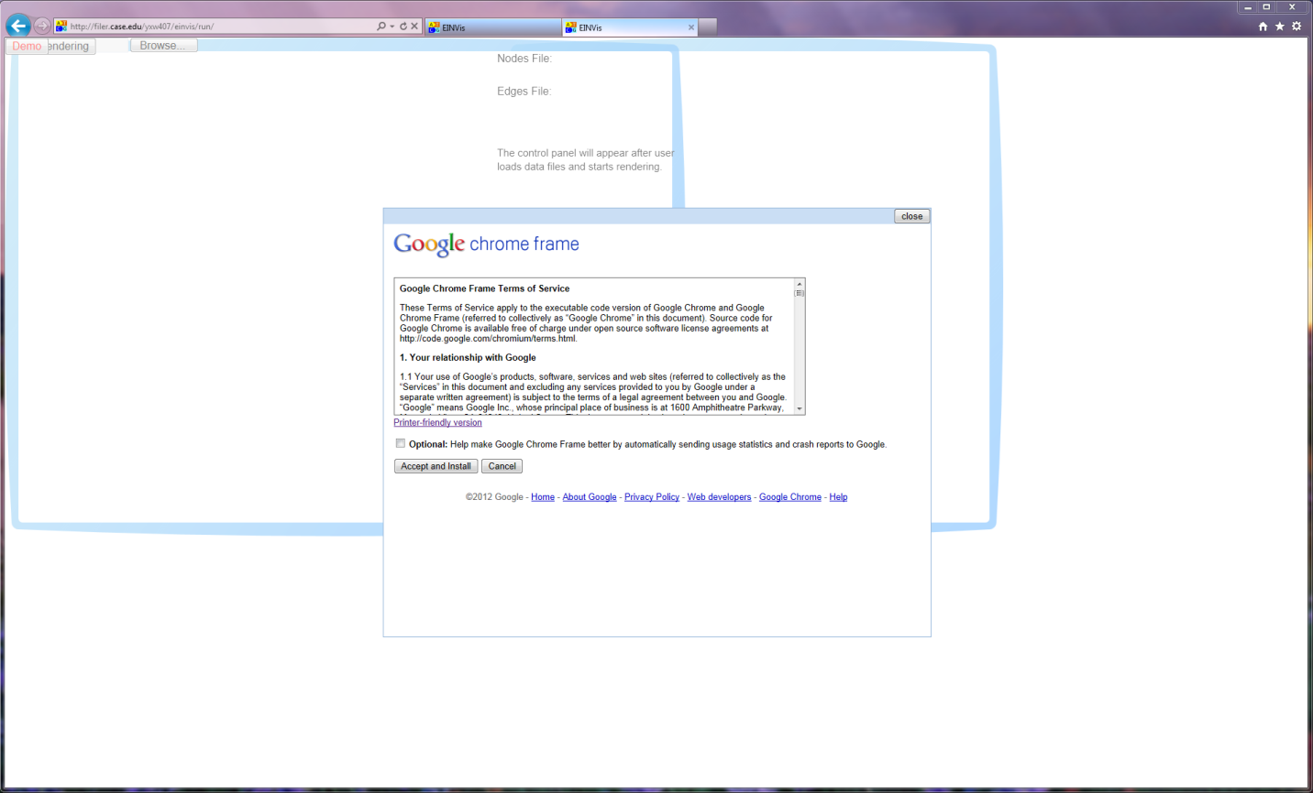

Fig. 5. Click “Accept and Install” to continue the installment of Google Chrome Frame.

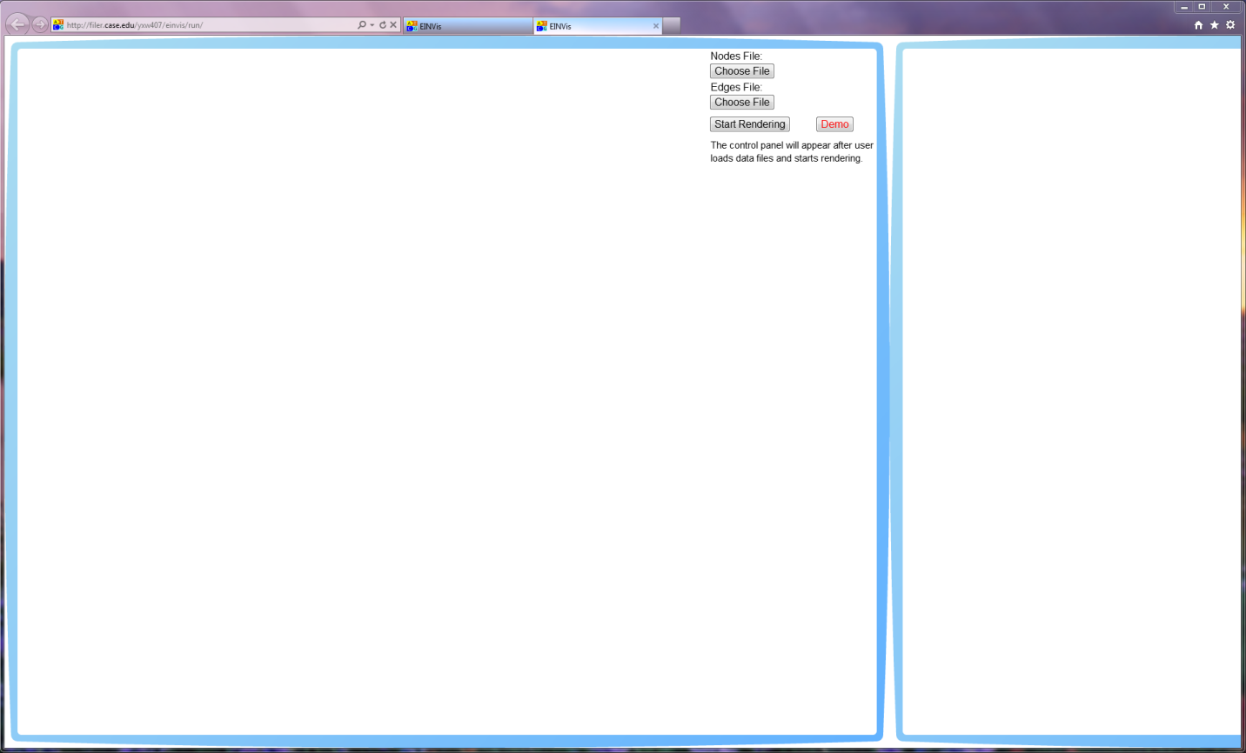

Fig. 6. The initial bubbles interface of EINVis.

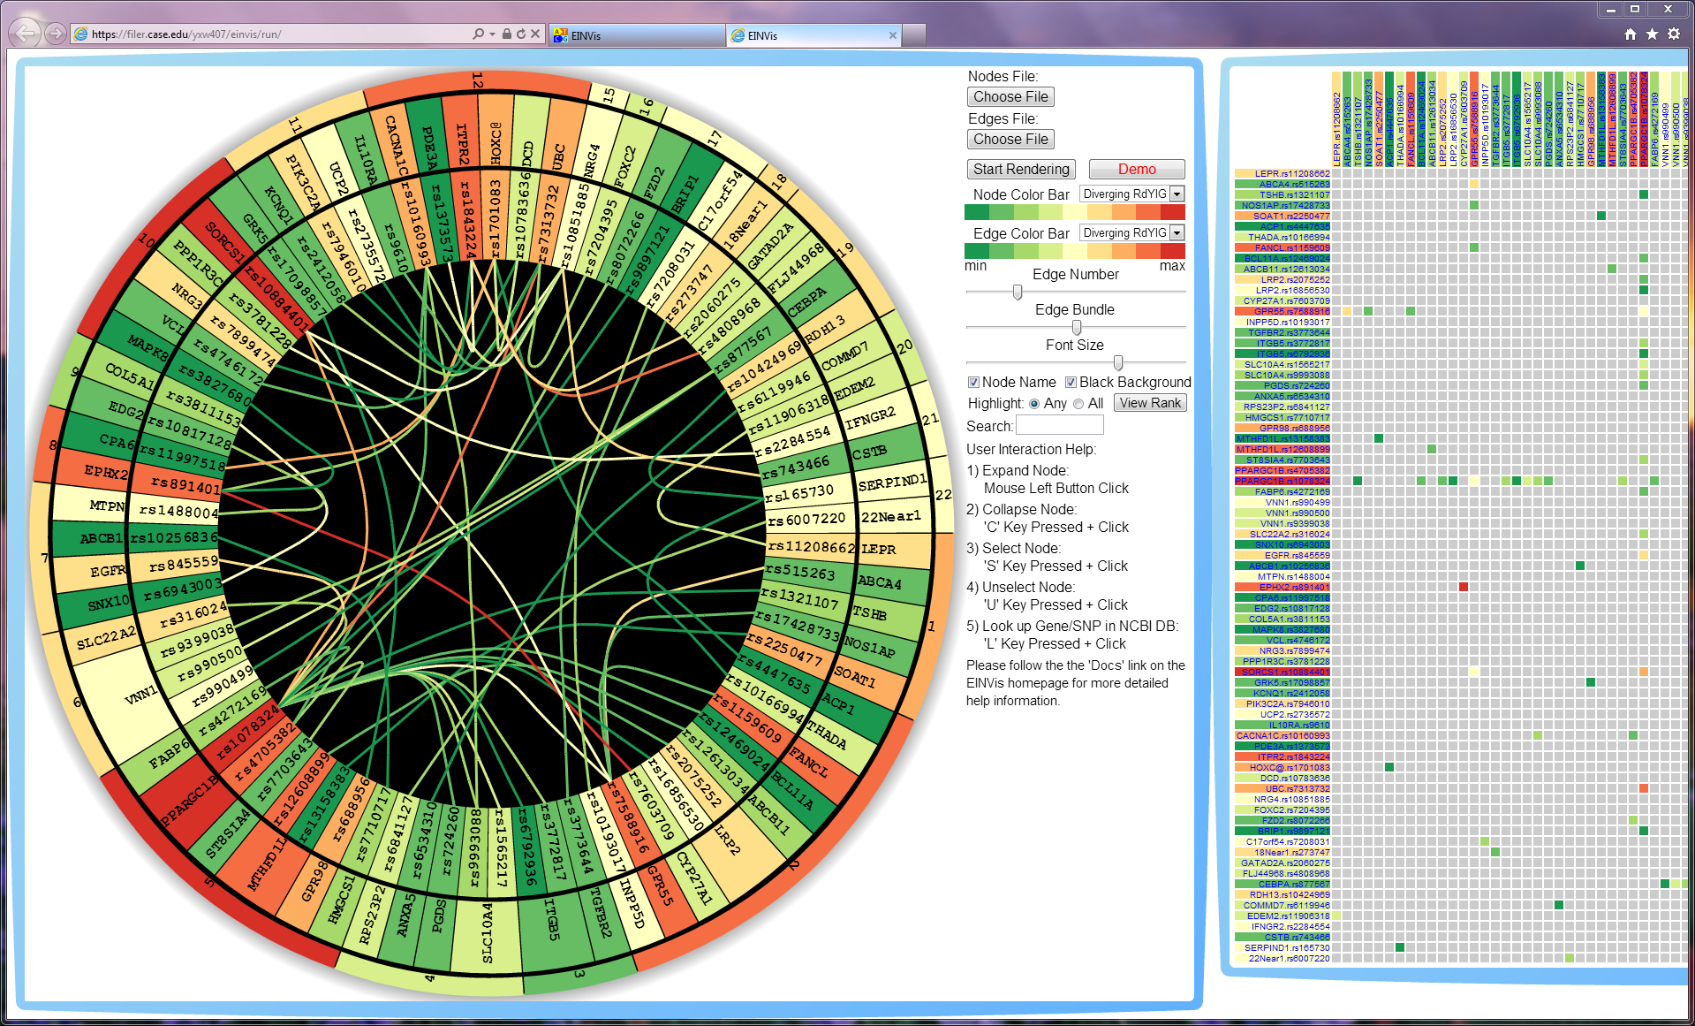

Fig. 7. Click red “Demo” button, we can see initial render results of two views. The left bubble is the EIN tree ring view. While the right bubble is the EIN matrix view.

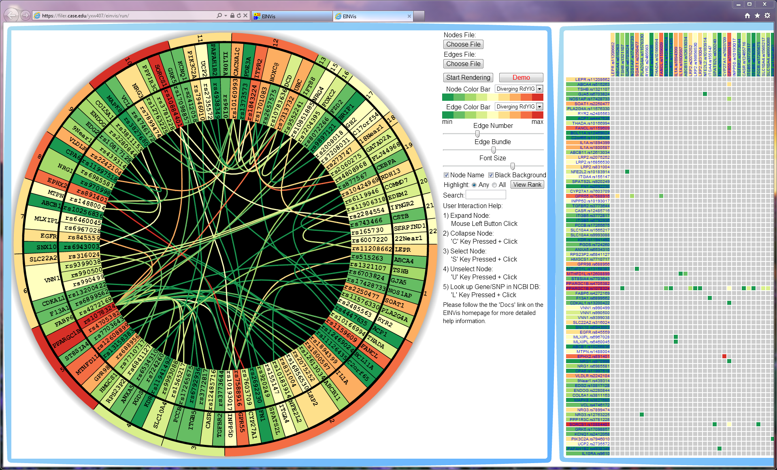

Fig. 8. Adjust the “Edge Number” slider to increase the number of edges and induced nodes.

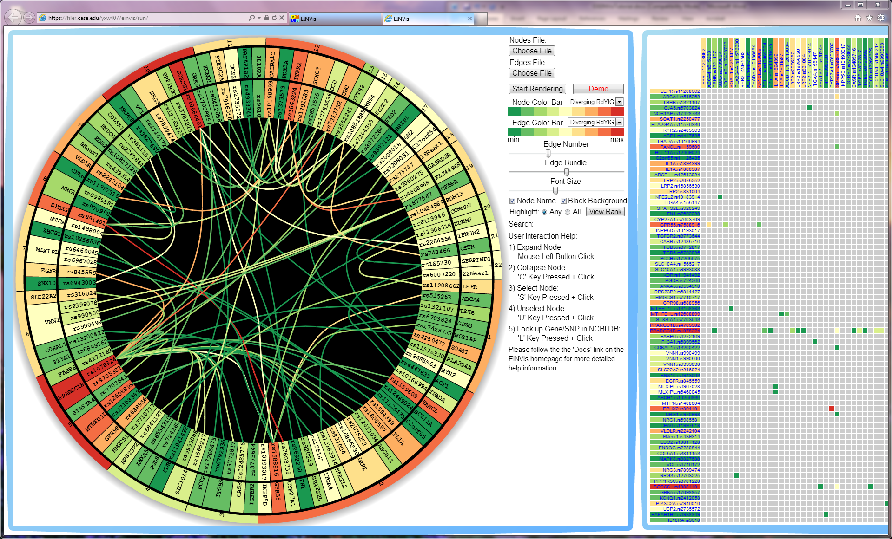

Fig. 9. Adjust the “Font Size” slider to decrease the font size of node name. The width of three levels in the ring will also decrease when the font size decreases.

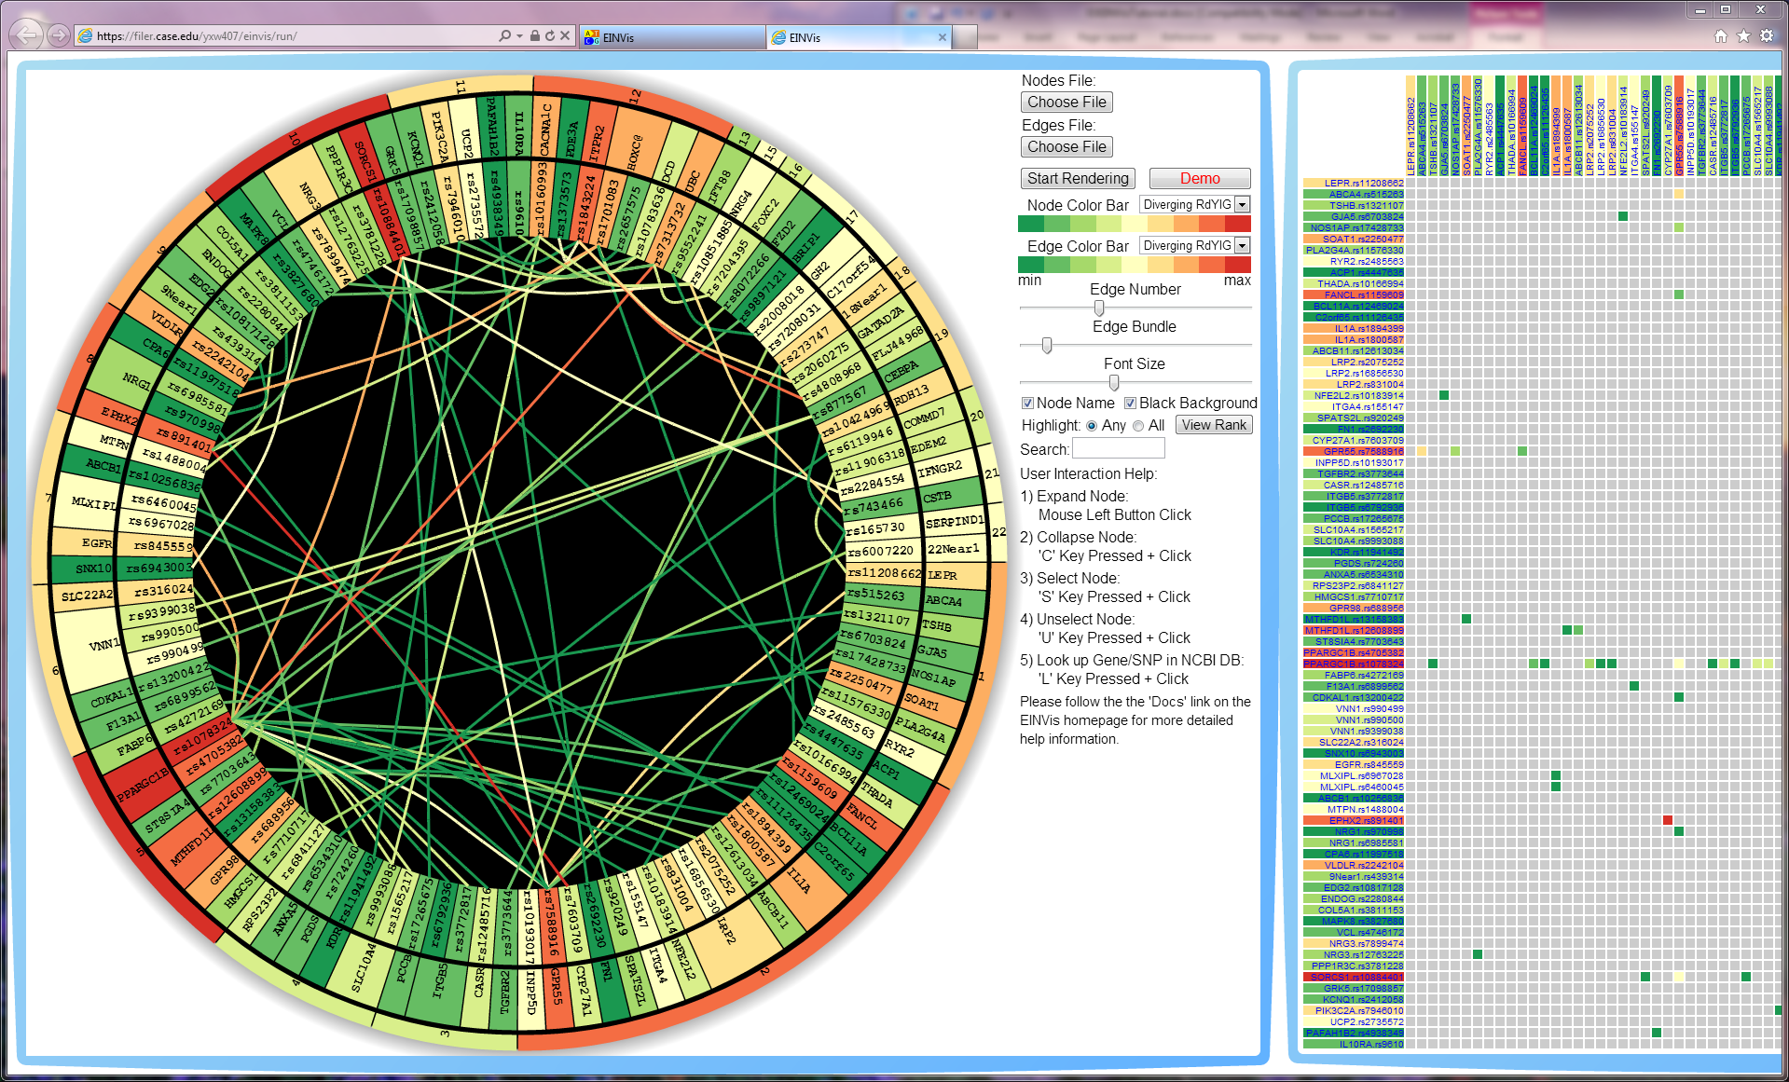

Fig. 10. Adjust “Edge Bundle” strength slider and the edges become straighter.

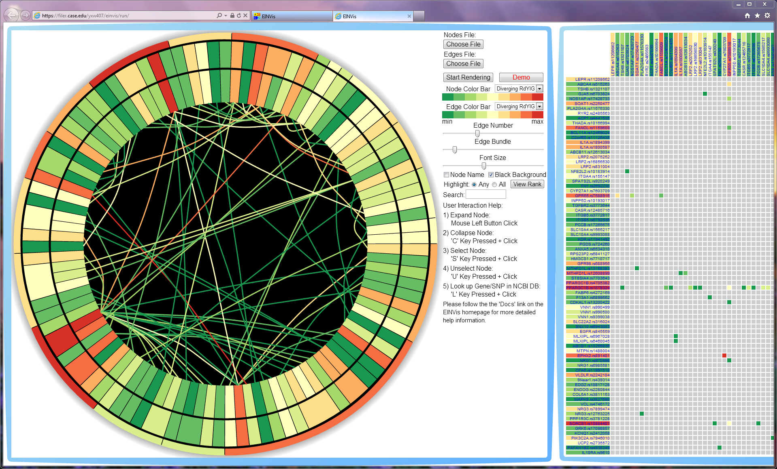

Fig. 11. Uncheck “Nodes Name” checkbox to hide the node name. Then the color pattern will become much clear.

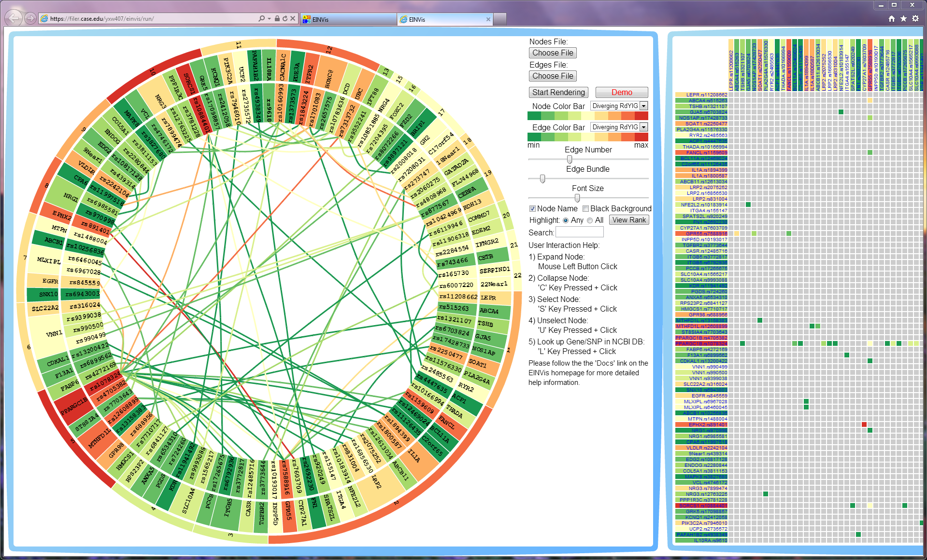

Fig. 12. Uncheck “Black Background” checkbox to show white background. Black background is better, since the edges with light color will become invisible under the white background.

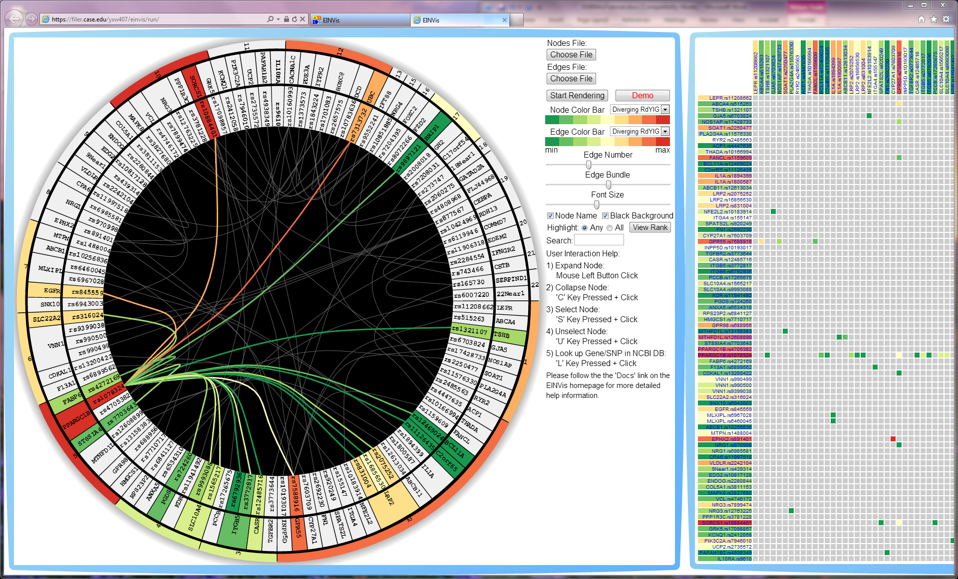

Fig. 13. “S”+Click to select one node “rs1078324”. All related nodes and induced edges will be highlighted with color, while unrelated ones become gray.

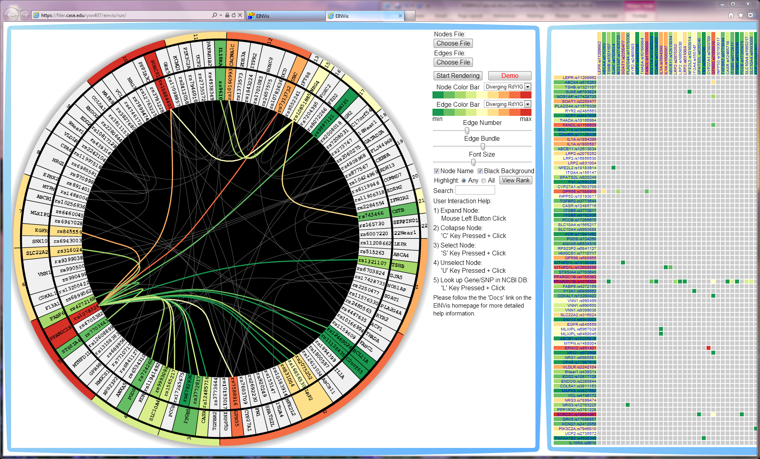

Fig. 14. “S”+Click to select another node “rs10851885”. All related nodes and induced edges will be highlighted with color, while unrelated ones become gray.

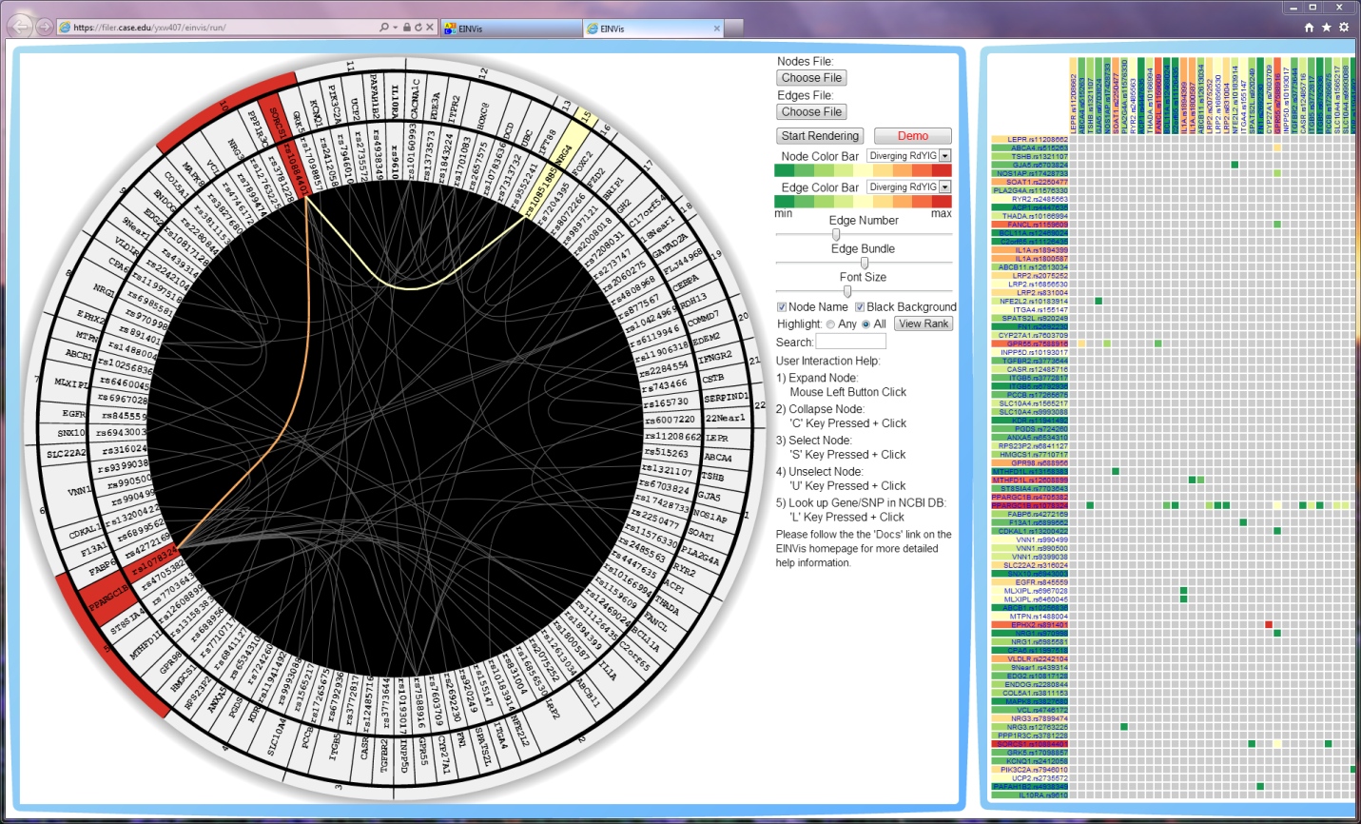

Fig. 15. Switch to highlight “All” radio, we can see that only one SNP “rs884401” interacts with both of the two selected SNPs “rs1078324” and “rs10851885”.

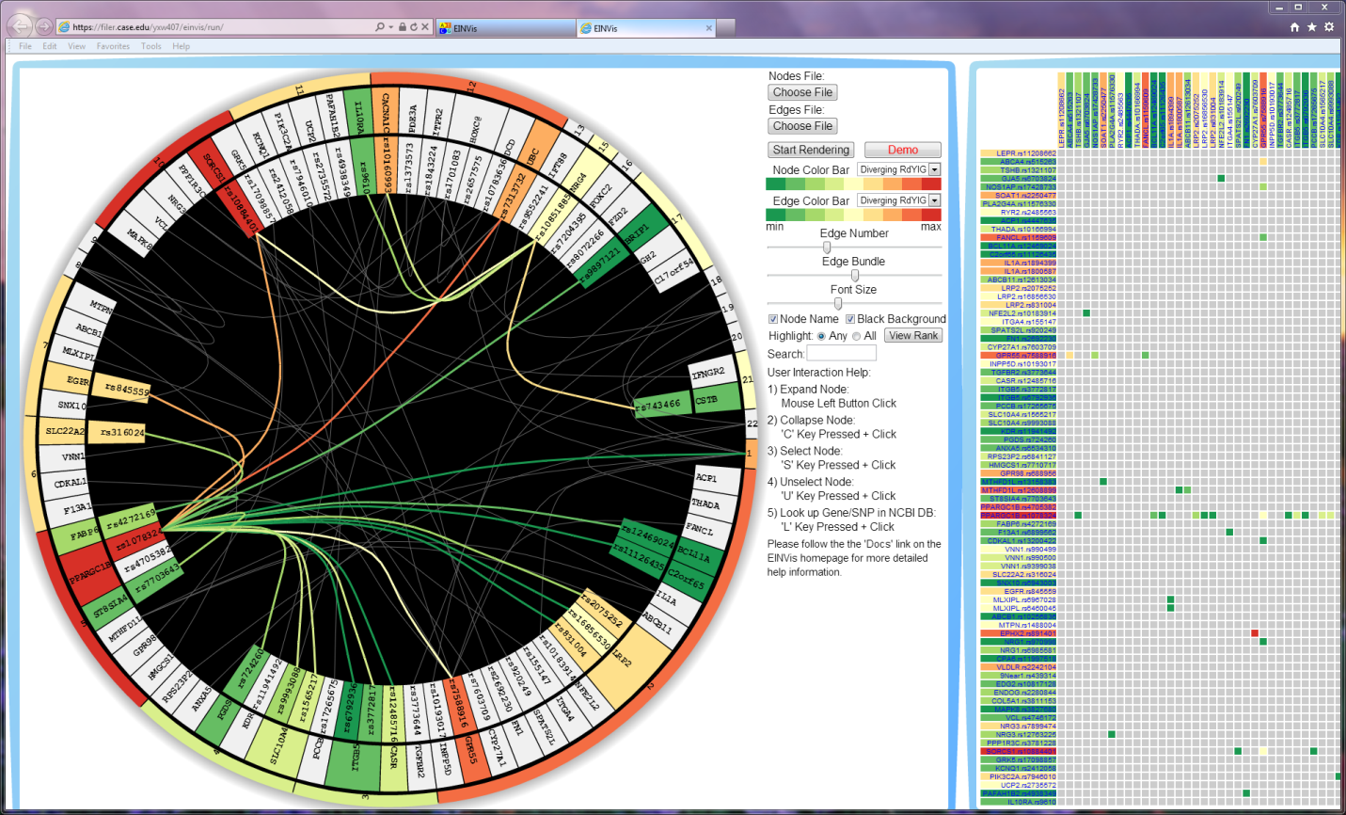

Fig. 16. “C”+Click to collapse some nodes, which are unrelated to the two selected SNPs.

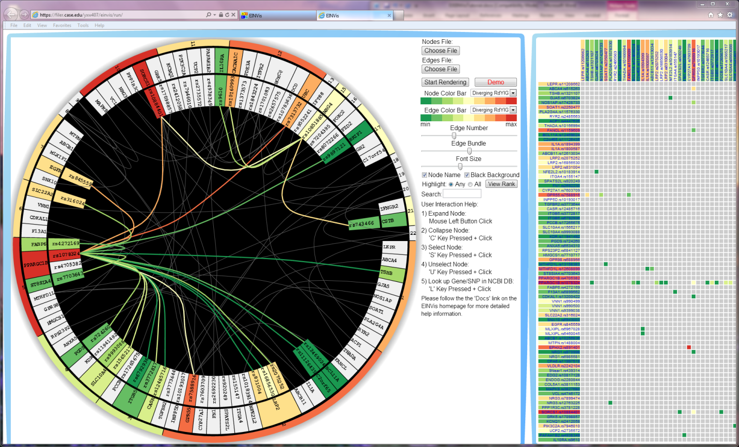

Fig. 17. Click to expand the chromosome node “1”. The user can re-expand the collapsed nodes.

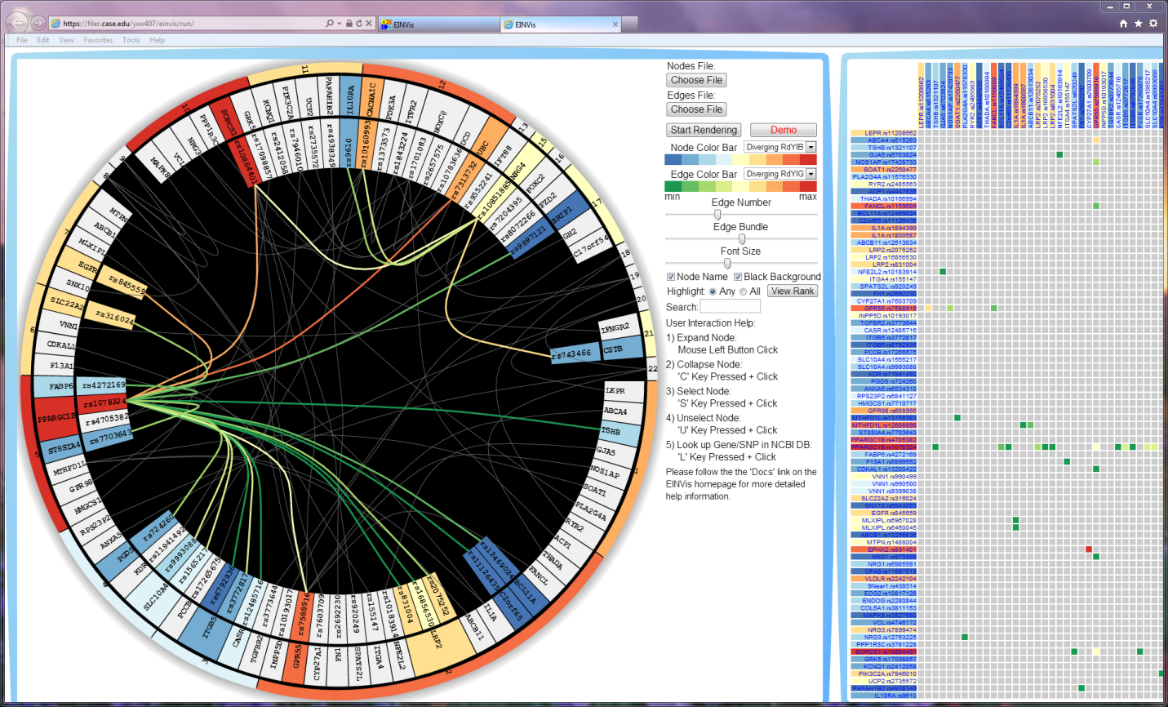

Fig. 18. Change the node color bar. We provide 13 different color bars, most of which are selected from ColorBrewer. These color bars are optimal for the user to distinguish the color differences.

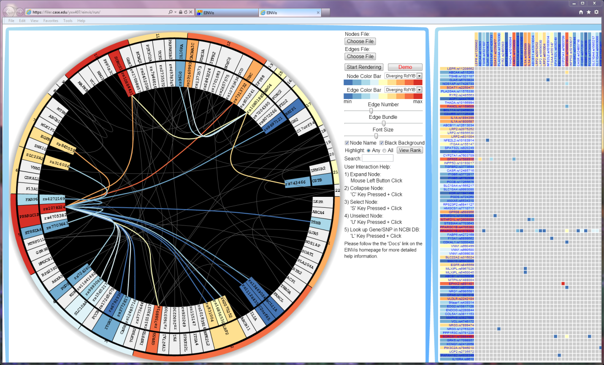

Fig. 19. Change the edge color bar. Node color bar and edge color bar share the 13 color bars. The user can configure the node color and edge color independently.

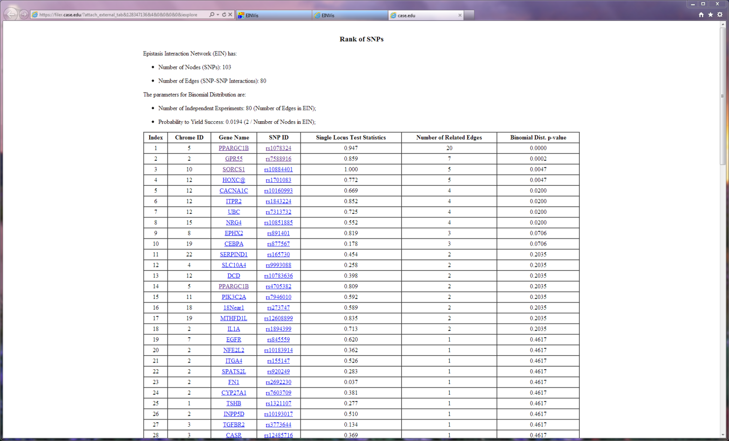

Fig. 20. Click on the “View Rank” button, EINVis will open a new webpage, and show the rank of SNPs. The screenshot above show the table of rank of SNPs.

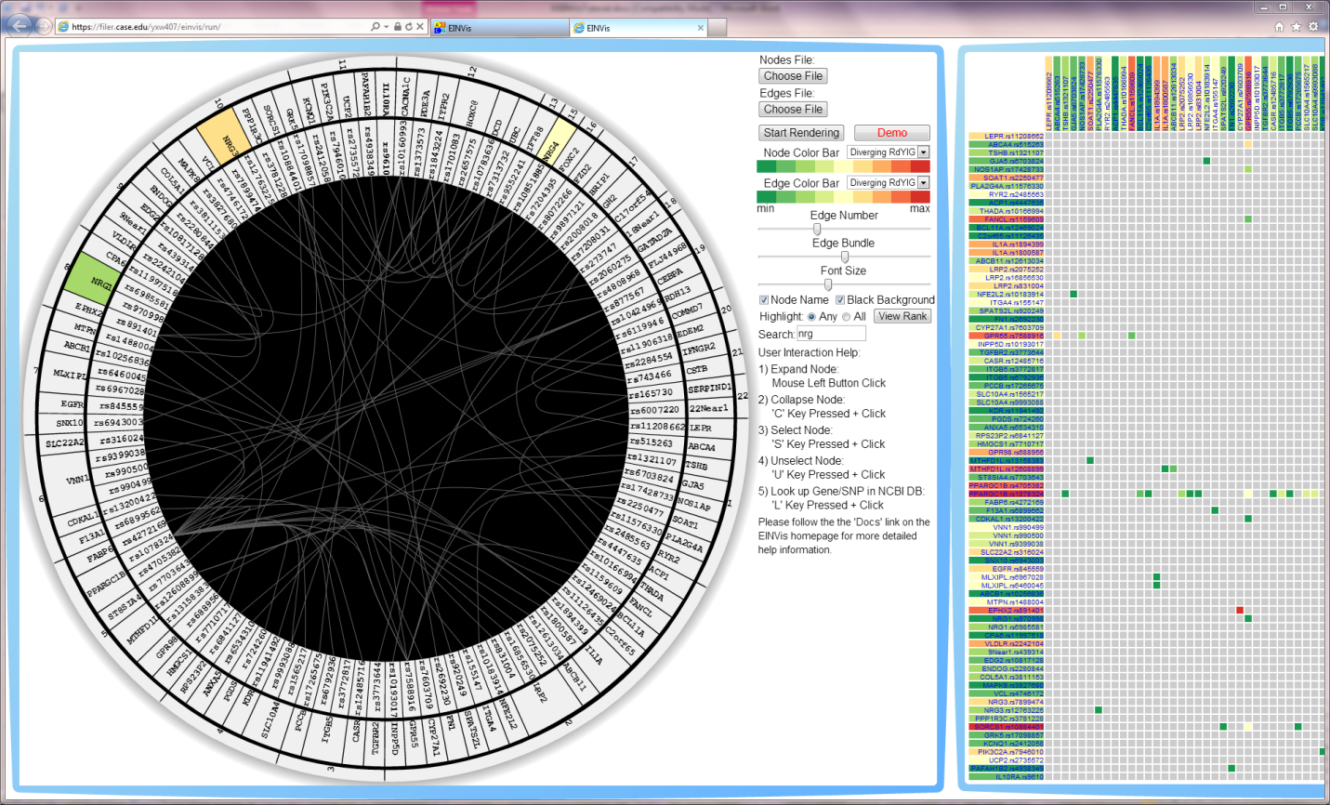

Fig. 21. When user search one gene name or SNP ID, the matching gene name or SNP ID will be highlighted with colors. The above screenshot shows that user search for “nrg”, and three gene names “NRG1”, “NRG3”, and “NRG4” are highlighted with colors.

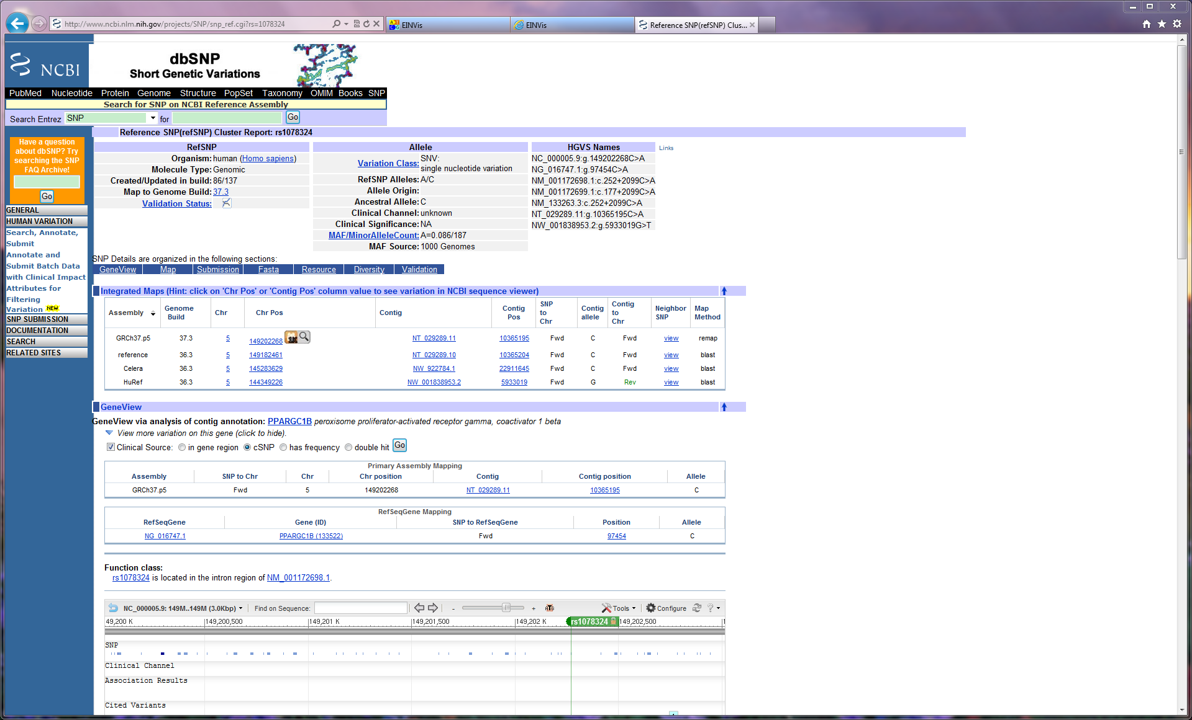

Fig. 22. “L”+Click to look up one SNP “rs1078324” in the NCBI database website. If the user wants more detailed information about one SNP, he/she can click the node and link to the NCBI website.

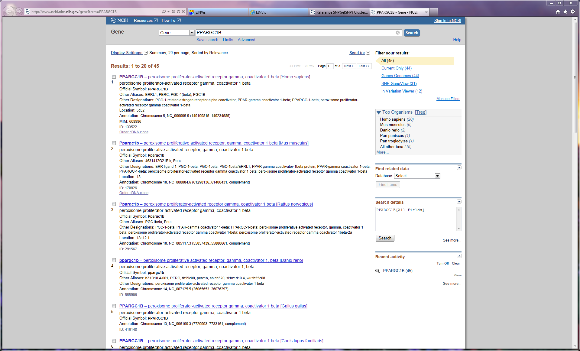

Fig. 23. “L”+Click to look up one Gene “PPARGC1B” in NCBI database website.

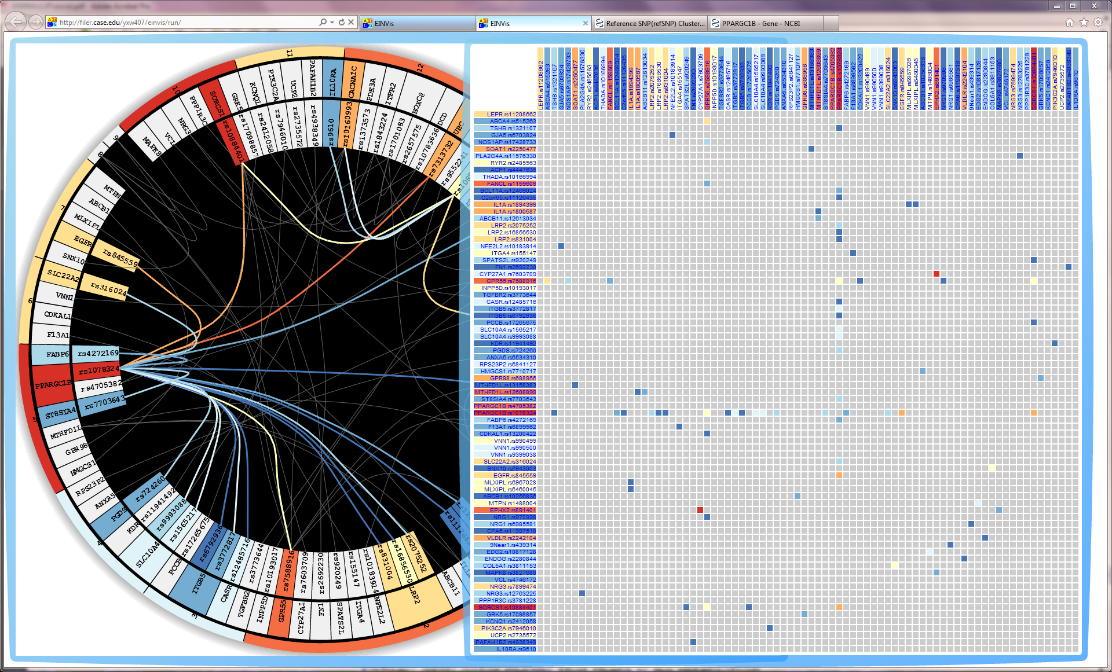

Fig. 24. Move the EIN matrix view bubble by dragging on the blue frame region of the bubble. The EIN matrix view has the same color scheme as in the EIN tree ring view.

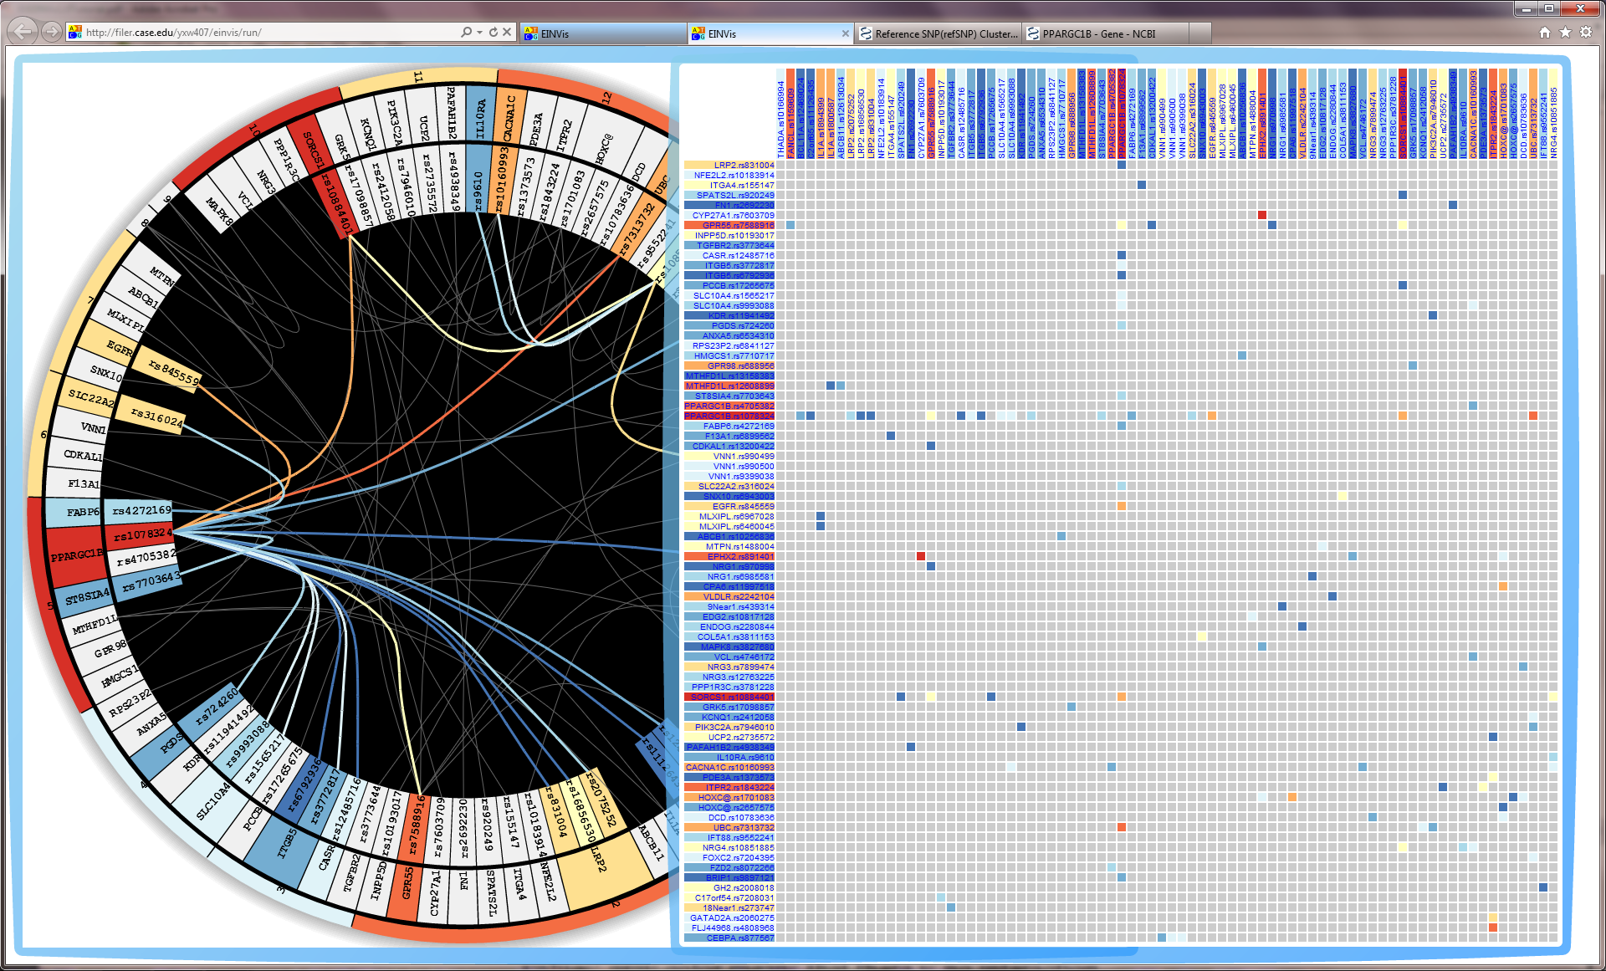

Fig. 25. Pan the EIN matrix view by dragging inside the EIN matrix view bubble. Since there maybe too many SNPs to show in the EIN matrix view, we provide the pan function to view different part of the matrix.

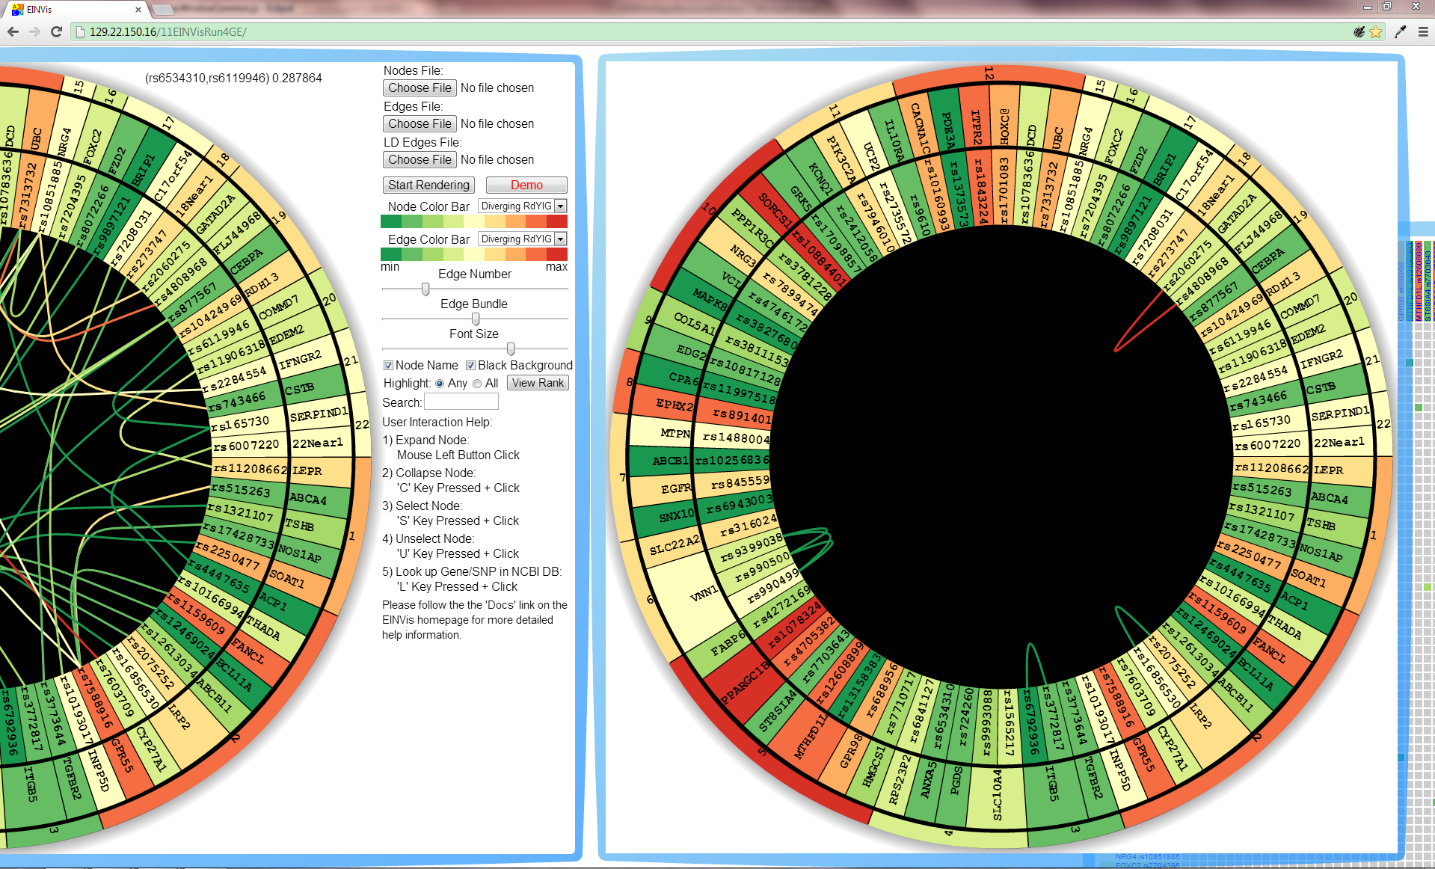

Fig. 26. The LD Tree Ring View. LD Tree Ring View has the same layout as the EIN Tree Ring View. The edges are replaced by the LD information between SNPs.

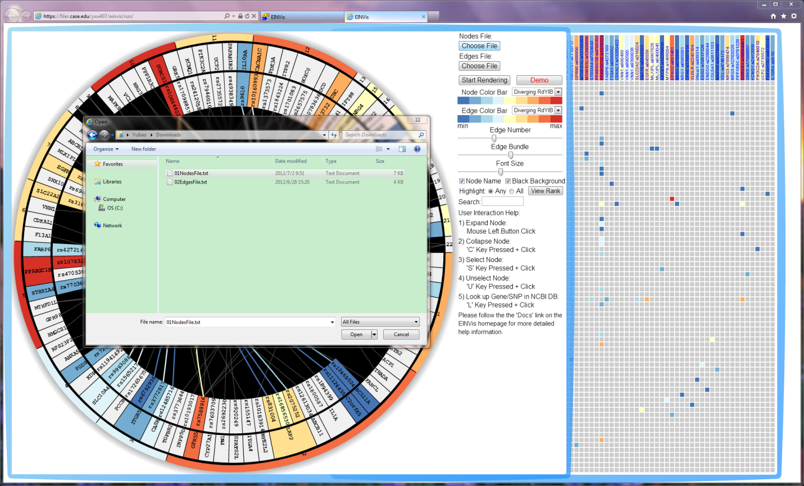

Fig. 27. Click the “Choose File” button under the “Nodes File” label to load a new Nodes file.

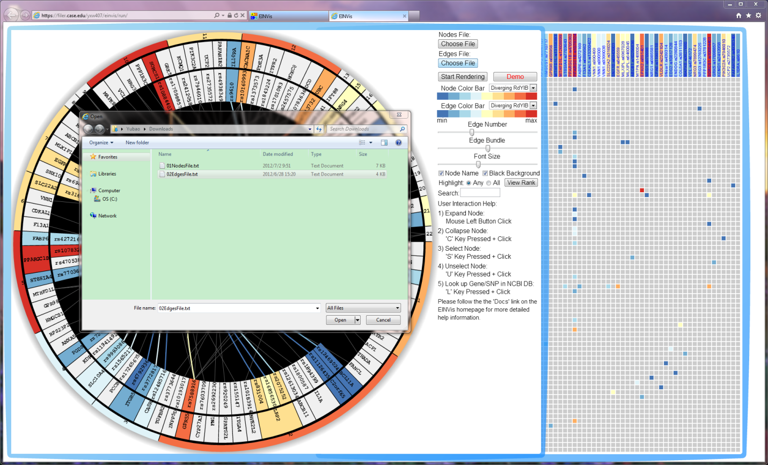

Fig. 28. Click the “Choose File” button under the “Edges File” label to load a new Edges file.

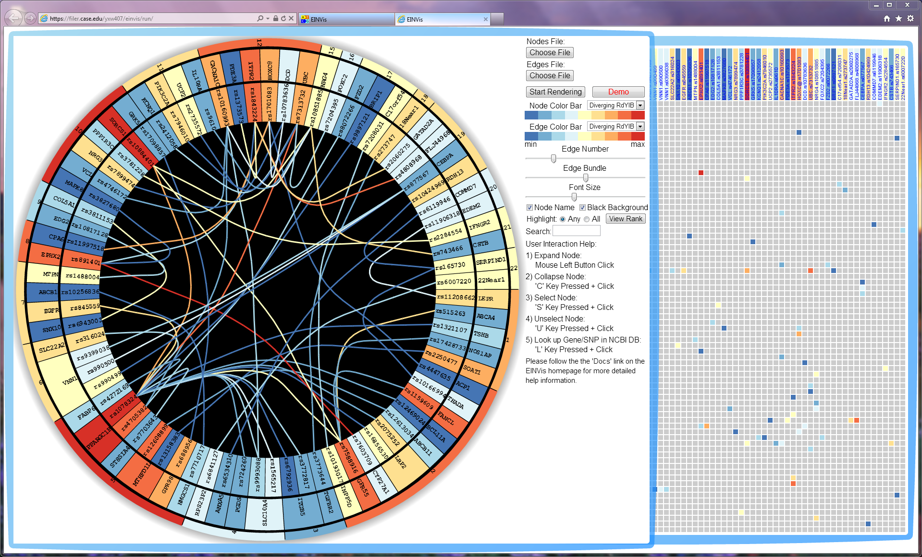

Fig. 29. Click the “Start Rendering” button to start rendering the views for the newly loaded dataset. The user can visualize their own dataset through the steps shown in Fig. 27, 28.